TightGate-Pro
Dediziertes Remote-Controlled Browser System
zum Schutz vor Gefahren aus dem Internet

Automatisch generierter Auszug aus dem Administrationshandbuch

Datum: 11.04.2019

Herausgeber:
m-privacy GmbH
Technische Redaktion
Werner-Voß-Damm 62
12101 Berlin
Fon: +49 30 243423-34

support@m-privacy.de
www.help.m-privacy.de

Allgemeine Hinweise zu diesem Handbuch
Alle Materialien und Ausführungen wurden mit Sorgfalt erarbeitet und zusammengestellt. Dennoch sind Fehler nicht auszuschließen. Die m-privacy GmbH übernimmt keine Haftung für Schäden, die aus Unrichtigkeit einzelner Angaben entstehen.
Im Sinne einer raschen Orientierung und zur Vermeidung von Sicherheitsrisiken werden besonders wichtige Aspekte durch wiederkehrende Stichworte gekennzeichnet. Diese sind:
Hinweis
Unter diesem Stichwort werden nützliche Details zur rationellen Verwendung von TightGate-Pro erläutert.
Achtung
Unter diesem Stichwort erfolgen Hinweise zur Problemvermeidung bzw. zur Vorbeugung von Betriebsstörungen bei TightGate-Pro.
Warnung
Unter diesem Stichwort erfolgen Hinweise auf mögliche Fehler bei der Konfiguration und Verwendung von TightGate-Pro, die weitreichende Sicherheitsrisiken bergen oder zu schwerwiegenden Betriebsstörungen führen können.

Inhaltsverzeichnis

Inhaltsverzeichnis
Use of the "TightGate-Pro Extension" for Chrome 1
Prerequisite 2
Installation of the TightGate-Pro extension 3
Setting up the extension 4
Using the TightGate-Pro extension 5
Uninstalling the extension 6
Troubleshooting 7

Use of the "TightGate-Pro Extension" for Chrome
These instructions describe step by step how the TightGate-Pro extension is installed, set up and used effectively. The extension was developed as a supplement to the ReCoB system TightGate-Pro to transfer links that link to the free Internet directly to the TightGate-Viewer.

Prerequisite
For the TightGate-Pro extension works, it is necessary that the software TightGate-Viewer version 4.3.9 or higher is installed and configured.
The software TightGate-Viewer can be downloaded here for free: https://www.m-privacy.de/download-center/
The installation and configuration of the TightGate-Viewer is described here: https://help.m-privacy.de/doku.php/tightgate-pro:client:windows-vnc

Installation of the TightGate-Pro extension
The TightGate-Pro extension is installed in the following steps:
- Open the Chrome Web Store in the Chrome browser via: https://chrome.google.com/webstore
- Enter the term TightGate-Pro extension in the search field of the Chrome Web Store and select the TightGate-Pro extension in the search results.
- Click on the button Add to Chrome and confirm the installation by clicking Add extension.

Setting up the extension
After the extension has been installed, the TightGate-Pro extension appears in the Chrome toolbar under Extensions. The extension is active immediately after installation and requires no further configuration.
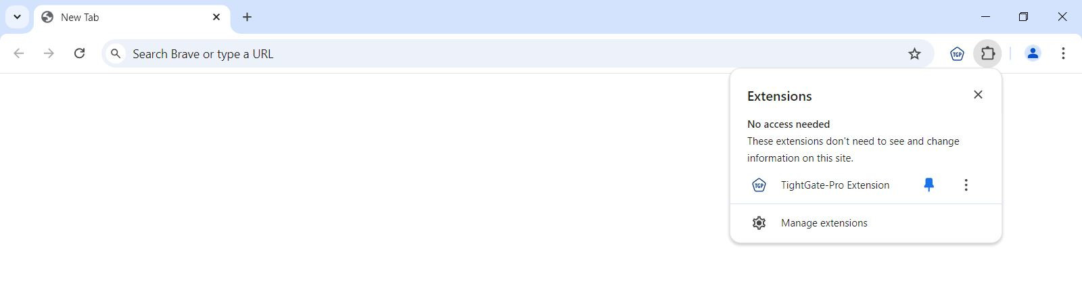
Tip The TightGate-Pro extension extension can also be pinned in the toolbar. To do this, click on the icon for extensions and select Pin right of the extension. If the TightGate-Pro extension is pinned to the toolbar, it can be switched on/off at any time by clicking on the application icon.

Using the TightGate-Pro extension
Using the TightGate-Pro extension is very simple. Once everything is set up and configured correctly, simply enter an Internet URL in the address bar of the Chrome browser and send it.
- A message window opens asking whether the URL in question should be opened with TightGate-Pro.
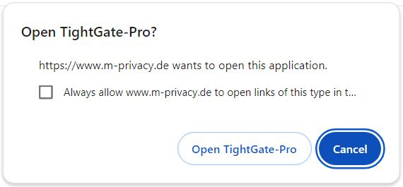
- Confirm the entry by clicking on the button Open TightGate-Pro.
- The link is now transferred to TightGate-Pro. If the TightGate-Viewer is already running in the background, it is brought to the foreground and the link is opened there in a new tab. If the TightGate-Viewer is not yet running, it is started automatically and the link is opened there.

Uninstalling the extension
Uninstalling the TightGate-Pro extension is done in the following steps:
- Click on the three-dot menu in the top right corner of Chrome.
- Go to Extensions > Manage Extensions.
- Select the TightGate-Pro extension and click on the Remove button.

Troubleshooting
If the message window for opening links in TightGate-Pro does not open, check the following:
- Is TightGate-Viewer installed? –> Solution: If TightGate-Viewer is not installed, the TightGate-Pro extension displays the following error page after installation:
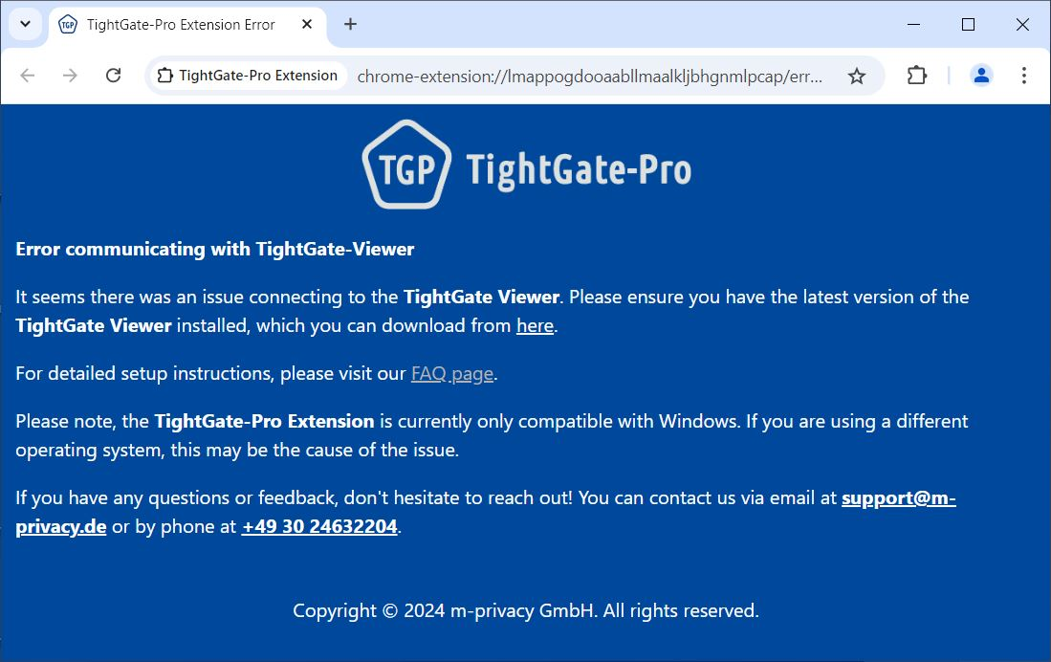
The TightGate-Viewer can be installed and configured as be installed and configured as described here.
- Is the TightGate-Pro extension active? –> See Setting up the extension.
- Is the link entered as internal in the URL_Whitelist.txt? –> See Instructions for configuring the whitelist.

